Linux User and Group Management Commands

1. useradd – Create a New User
useradd -g groupname username → Assigns primary group to the user

useradd -u UID username → Creates user with a custom UID

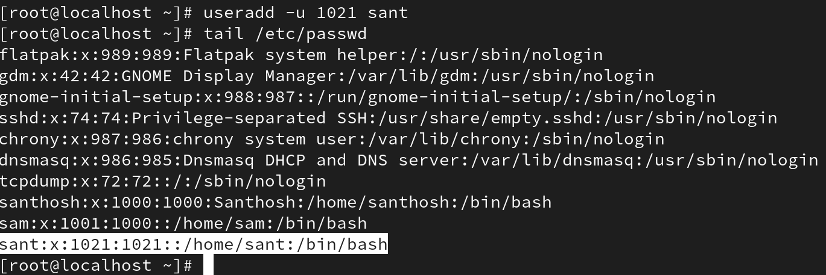

useradd -c "comment" username → Adds a comment/purpose (stored in /etc/passwd)

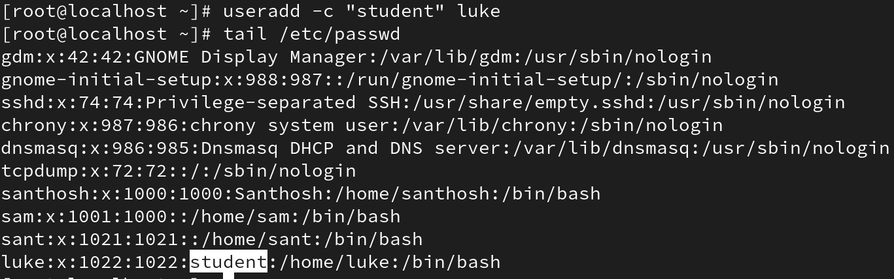

useradd -d /custom/home username → Sets a custom home directory

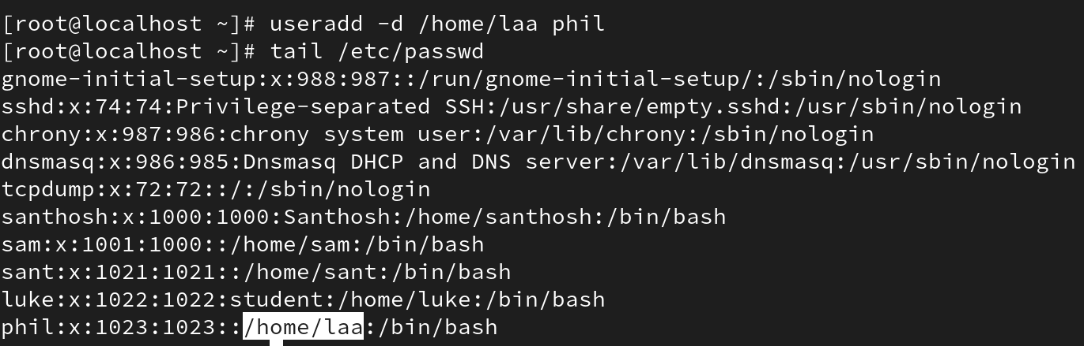

useradd -s /bin/sh username → Sets a default shell (e.g., bash, sh, etc.)

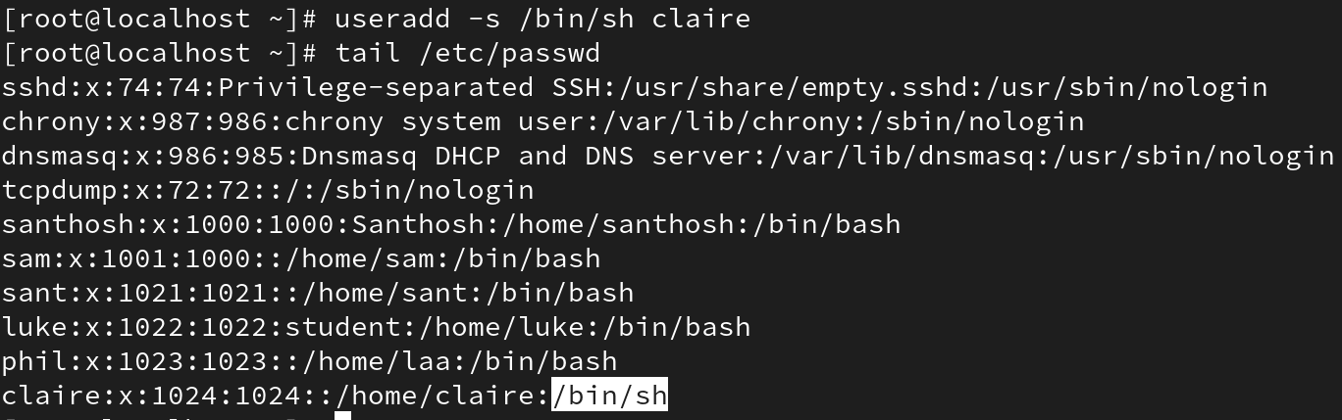

useradd -M username → Creates a user without a home directory

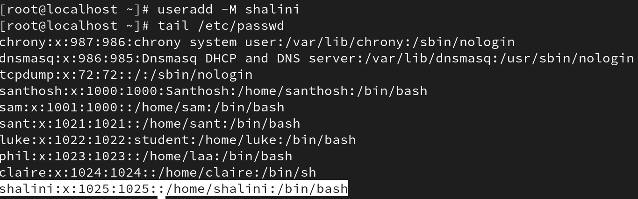

useradd -e "YYYY-MM-DD" username → Sets an expiry date (temporary user)

Example (combine options):
useradd -u 1u500 -g developers -c "Project User" -d /data/user1 -s /bin/bash -e "2025-12-31" username

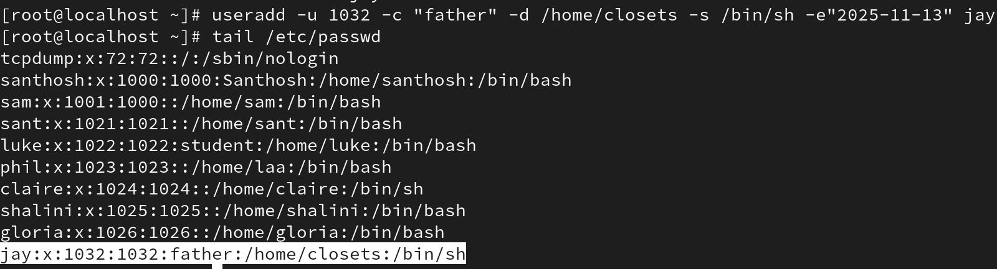

2. usermod – Modify Existing Users
usermod -l newname oldname → Change login name (username only, UID remains)

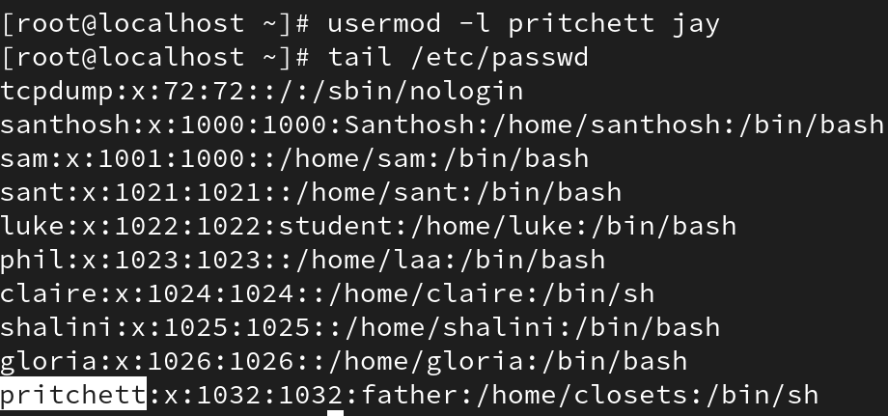

usermod -u newUID username → Change UID (must be unused)

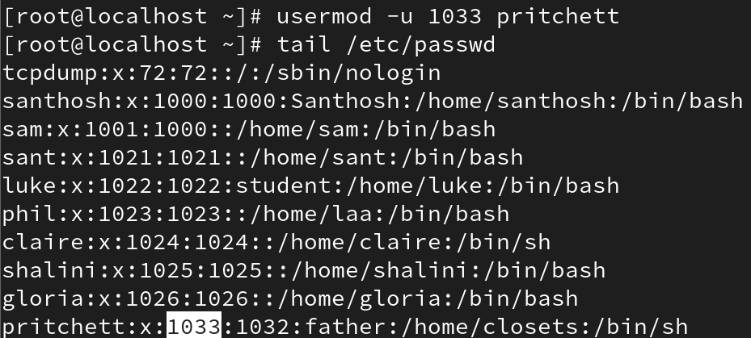

usermod -g newGID username → Change primary group

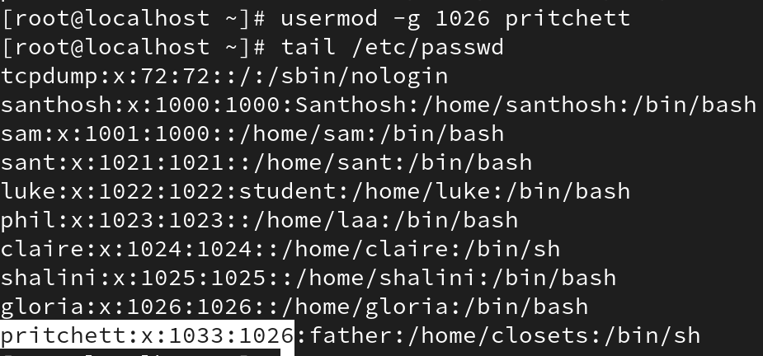

usermod -c "new comment" username → Change comment/purpose

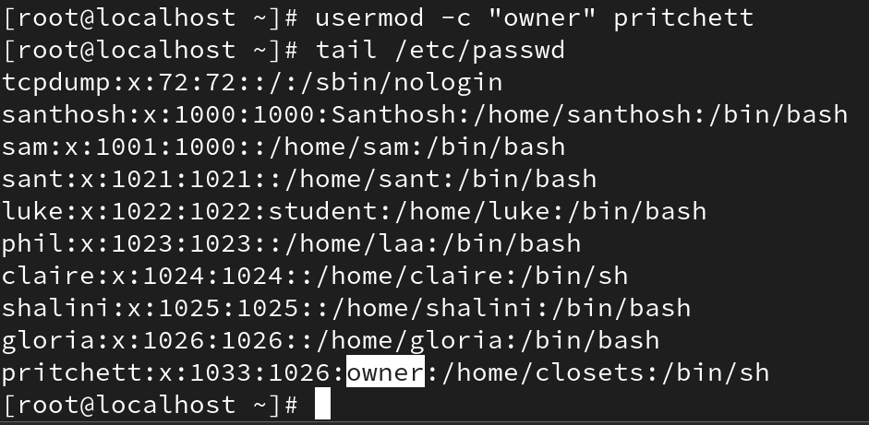

usermod -d /new/home username → Change home directory

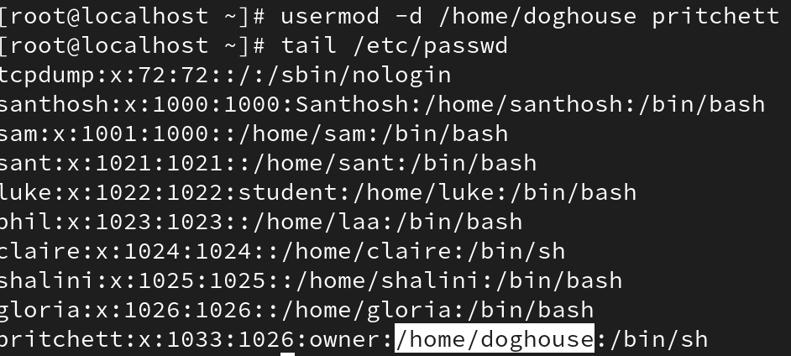

usermod -s /bin/sh username → Change default shell

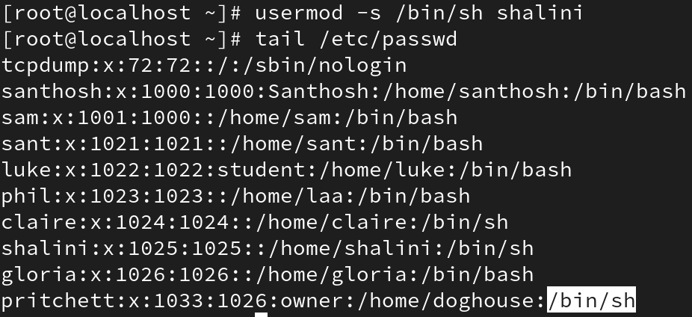

Example (combine options):
usermod -u 1600 -g admins -c "Admin User" -d /opt/admin -s /bin/sh oldusername
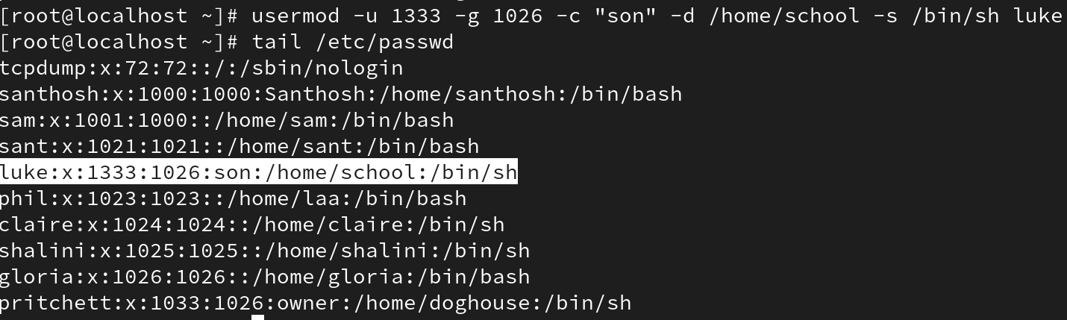

3. Locking and Unlocking Accounts
usermod -L username → Lock account (!! Means account is locked)

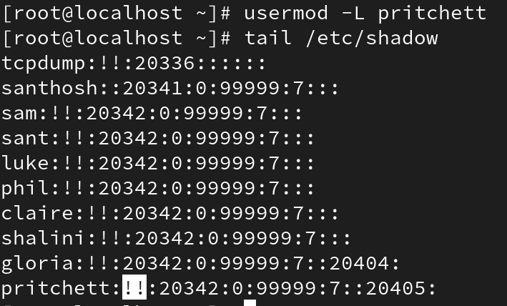

usermod -U username → Unlock account

4. chage – Password and Expiry Management
chage -l username → Show password aging details

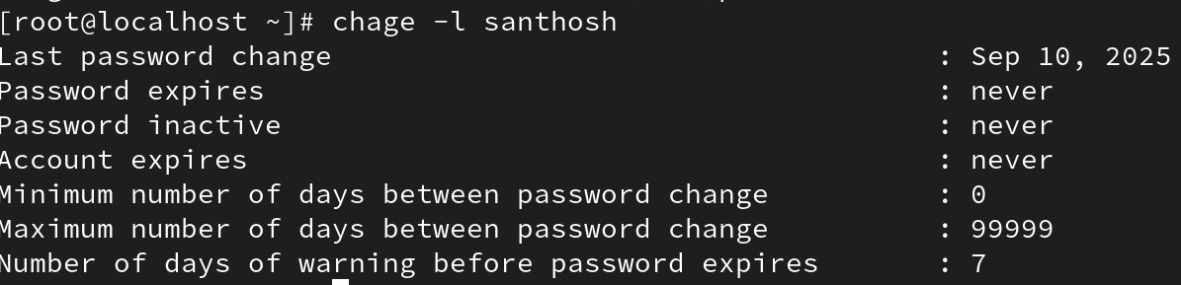

chage -m 5 username → Set minimum 5 days before password change allowed

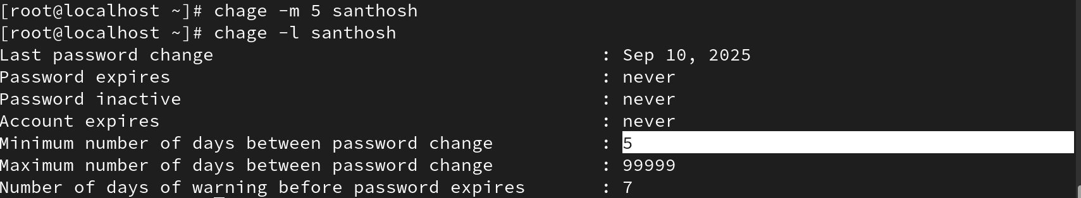

chage -M 90 username → Set maximum 90 days validity for password

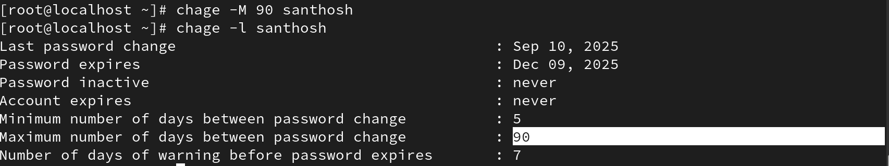

chage -W 10 username → Warn user 10 days before password expiry

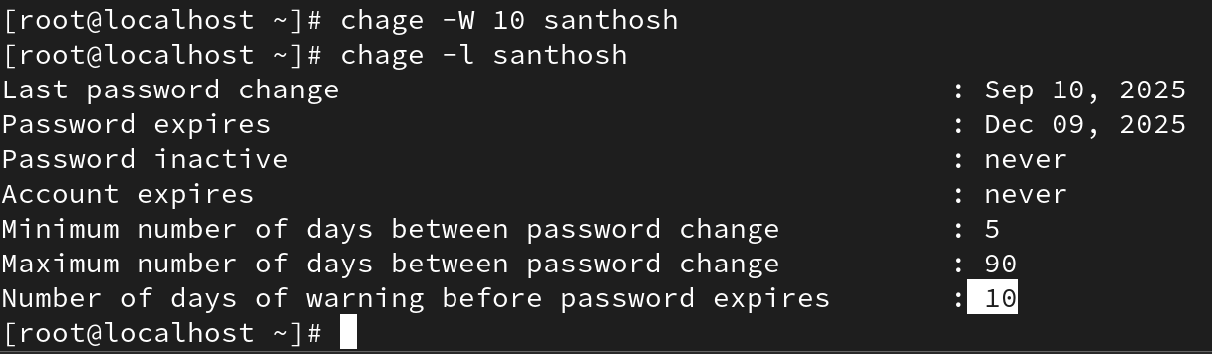

chage -E "2026-01-31" username → Set account expiry date

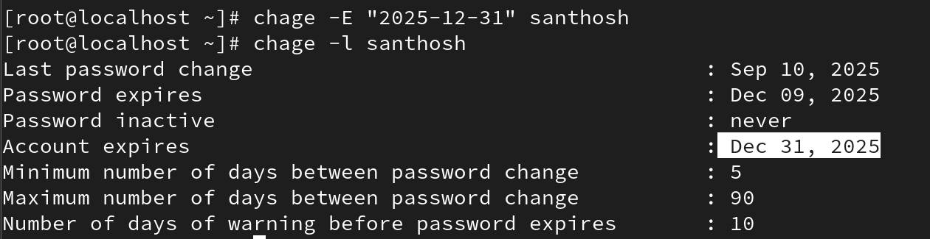

chage -d 0 username → Force user to change password at next login

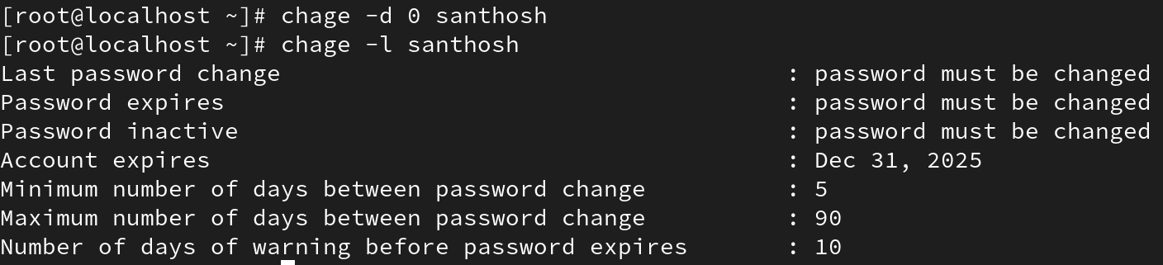

chage username → Interactive mode to set all values

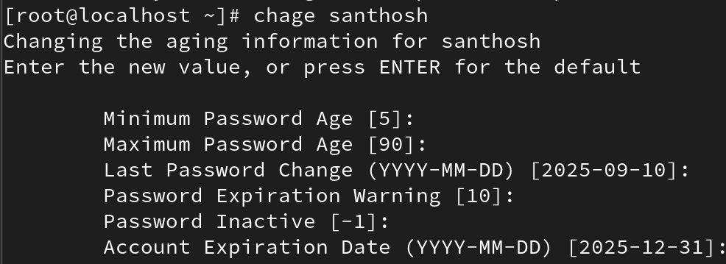

5. groupmod – Modify Groups
groupmod -n newname oldname → Rename a group

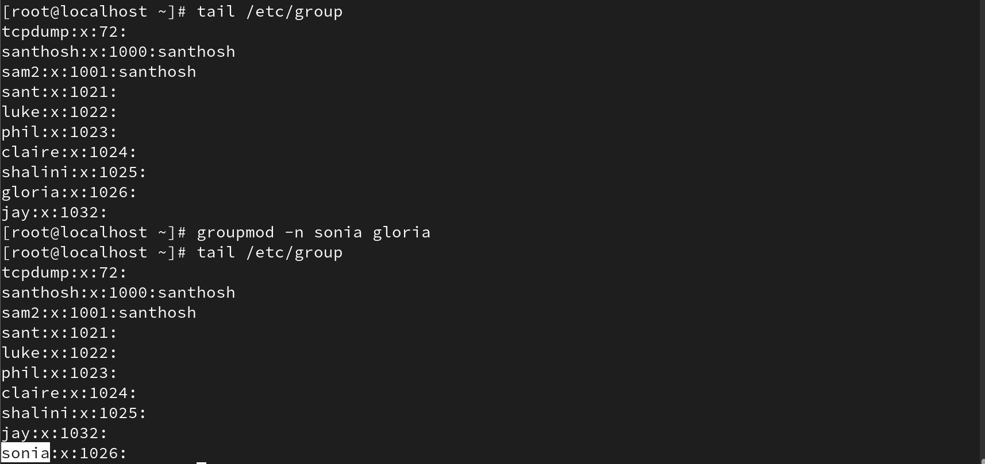

groupmod -g newGID groupname → Change group ID

